**Add Specified Text To The Beginning / End Of All Cells With VBA**

If you want to add specified text in each cells of a selection directly, the following VBA Macro will ease your work.

**1**. Select the range in which you will add specified text;

**2**. Hold down the **Alt** + **F11** keys in Excel, and it opens the **Microsoft Visual Basic for Applications** window.

**3**. Click **Insert** > **Module**, and paste the following VBA code in the Module Window.

**VBA: Adding specified text at the beginning of each cell:**

|  |  |
| --- | --- |
| 1  2  3  4  5  6 | Sub AppendToExistingOnLeft()  Dim c As Range  For Each c In Selection  If c.Value <> "" Then c.Value = "CN- " & c.Value  Next  End Sub |

**4**. Press **F5** key to run this macro. And all of the cells will be added the value ***CN-*** before the cell contents.

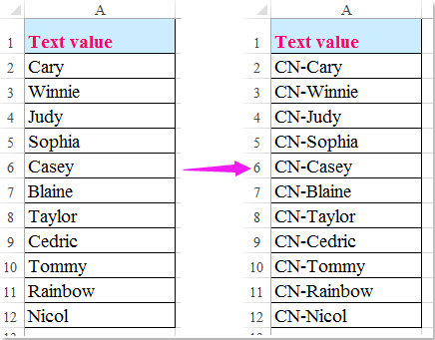

**Notes:** 1. To add some specific text at the end of each cell, please apply the following VBA code.

**VBA: Adding specified text at the end of each cell:**

|  |  |
| --- | --- |
| 1  2  3  4  5  6 | Sub AppendToExistingOnRight()  Dim c as range  For each c in Selection  If c.value <> "" Then c.value = c.value & "-CN"  Next  End Sub |

And you will get the following result:

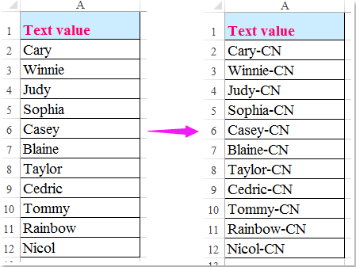

2. you can change the variable "***CN-***" or "***-CN***" of the above codes.